Detection of file modification and synchronous mechanism Implementation in NovaPIM System

A Thesis
in Computer Science

Presented to

The Faculty of the
International College, Zhejiang University of Technology

In Fulfillment
of the Requirements for the Bachelor’s
Degree Computer Science

by

Yuchao Zhou

May, 2013

On my honor as a University student, on this assignment I have neither given nor received unauthorized aid as defined by the Honor Guidelines for Papers in CS Courses.

Signed Yuchao Zhou

Approved Lianghuai Yang (Technical Advisor)

Approved Huiqiang Lv

中文摘要
近年来，个人信息急剧膨胀。所以，越来越多的人依赖个人信息管理系统来管理他们的个人数据。优秀的个人信息管理系统可以在大量的数据中，快速地定位用户想要的数据；可以有效的优化个人数据在本地系统的存储。本文的工作是在现有的NovaPIM系统上优化它。增加了对本地文件系统变更的监视，并且实现了将文件系统的变更同步到NovaPIM系统中等功能。论文的主要贡献：
- 实现了在一段时间内（30分钟），在NovaPIM系统之外，对文件系统变更的监测，即监测在NovaPIM系统中引用的文件的变更，如重命名文件，更改文件存放的目录等。并且将这些变更记录变更到日志中。
- 制定了运算规则，即建立了在一段时间内，针对同一文件的一系列操作的合并机制。
- 构建了合适的索引机制，使得NovaPIM系统能够快速定位变更的文件，并且同步变更。

本文详细介绍了NovaPIM系统中对文件系统变更的监测和实现同步技术的分析、设计与实现过程。

关键字：NovaPIM，文件系统检测，索引机制

Abstract
In recent years, personal information explodes dramatically. As a result, more and more people relay on some personal information management system to handle their personal data. One outstanding personal information management system can quickly locate the specific data which user wants among high volume of the whole data in the file system; can optimize the storage of personal data in local file system. The work of this thesis is based on the existed NovaPIM system, and improves it. Adding functions that detecting modifications of local file system occurred by user outside of the NovaPIM system, and synchronize all those modifications to it. Major contributions in thesis:
- Implemented the detection to the alterations made by user outside of the NovaPIM system in local file system for a regular session (30 minutes). That means detection the modifications to all files which are referenced in the NovaPIM system, such as, rename one file, or move one file into another directory. In the meantime, it will record all these changes into a log.
- Establishing a merging rule to deal with the series of operations with regard to one specific file in a session.
- Establish one suitable index mechanism to let the NovaPIM system can locate all those modified files quickly, and synchronize alterations to it.

In this report, detailed information about the detection of modifications in local file system and the implementation of synchronize technology would be introduced, including the process of analyse, design and implementation.

Keyword: NovaPIM, file system detection, index mechanism
中文目录
中文摘要 3
英文摘要 4
第一章 导论 1
1.1. 问题背景 1
1.2. 当前状况 2
1.3. 项目意义 2
1.4. 报告概括 3
第二章 可行性分析 4
2.1. 组织和管理的可行性 4
2.2. 经济上的可行性 4
2.3. 技术上的可行性 5
第三章 需求分析 6
3.1. 用户群体分析 6
3.2. 用例 7
3.3. 功能性分析 9
3.3.1.日历视图 11
3.3.2.添加，删除，修改日程 11
3.3.3. 搜索 12
3.3.4. 快速添加日程项 12
3.3.5. 其他 12
3.4. 需求跟踪矩阵 9
第四章 系统设计 15
4.1. 原型设计 15
4.1.1. 原型 15
4.1.2. 系统模块描述 20
4.2. 数据库设计 22
4.2.1. 概括 22
4.2.2. 数据库选择 22
4.2.3. 数据库概念设计 23
4.2.4. 数据库逻辑设计 25
4.3. 算法设计 26
4.3.1. 安排重叠日程项显示的算法 26
4.3.2. 生成快速日历项的算法 27
第五章系统实现 31
5.1. 概括 31
5.2. 开发工具 34
5.2.1. Derby (Java DB) 34
3.4.2. Eclipse 34
5.2.3. Java 34
5.2.4. JDK 35
5.2.4. Git and Bitbucket 35
5.2.5. Vim 36
5.2.6. Maven 36
5.3. 系统架构 36
5.4. 类图 39
5.4.1. 类之间关系 41
5.4.2. MainWindow.java 类 42
5.4.3. EventController.java 类 43
5.4.4. CalendarView.java类 44
5.4.5. JdbcDB.java类 45
5.4.6. EventDB.java类 46
5.4.7. Indexer.java类 47
5.4.8. SearcherLucene.java类 48
5.4.9. EventRectangle.java类 49
5.5. 系统模块实现 45
5.5.1. 实现过程中的挑战 45
5.5.1.1占据多天的日历项 45
5.5.1.2重用代码的努力 46
5.5.3. 添加一个日程项的实现 52
5.5.4. 在各个试图中显示日历项的实现 55
第六章 系统测试 60
6.1. 测试概览 60
6.2. JUnit 自动测试 60
6.3. 手动测试 60
6.2.1 连接数据库 60
6.2.2 添加事件 60
6.2.3 显示事件 60
6.2.3 添加快速事件 60
第七章 总结 64
参考文献 65
参考书目 68
致谢 69
附录 70
其余类图 70
DayView.java 类 70
DayCanvas.java 类 71
TranslucentRoundedRectangle.java类 71
EventEntity.java类 72

Content
中文摘要 3
I. Abstract 4
Chapter 1 Introduction 1
1.1. Problem Context 1
1.2. Current Situation 2
1.3. Project Significance 2
1.4. Report Overview 3
Chapter 2 Feasibility Analysis 4
2.1. The Feasibility of Organizing and Management 4
2.2. Economic Feasibility 4
2.3. Technical Feasibility 5
Chapter 3 Requirement Analysis 6
3.1. User Group Analysis 6
3.2 Use Case 7
3.3. Function Analysis 11
3.3.1.Calendar Views 11
3.3.2. Add, Edit, and Delete Appointment 11
3.3.3. Search 12
3.3.4. Quick Add 12
3.3.5. Miscellaneous 12
3.4 Requirement Trace Matrix 12
Chapter 4 System Design 15
4.1. Prototype Design 15
4.1.1. Prototypes 15
4.1.1.1. “Day View” prototype 15
4.1.1.2. “Month View” prototype 16
4.1.1.3. “Year View” prototype 17
4.1.1.4. “Week view” prototype 18
4.1.1.5. “Add, delete, and edit event” prototype 18
4.1.1.6. Search and search result prototype 19
4.1.1.7. “Go to date” prototype 20
4.1.2. System Components Description 20
4.1.2.1 Menu Block 20
4.1.2.2 Event Controller 21
4.1.2.3 Search 21
4.1.2.4 Graphical User Interface 21
4.1.2.5 Natural Language Processing 22
4.2. Database Design 22
4.2.1. Overview 22
4.2.2. Database Choose 22
4.2.3. Conceptual Database Design 23
4.2.3.1. The E-R diagram of calentries table 23
4.2.3.2. The E-R diagram of options table 24
4.2.4. Logical Database Design 25
4.2.4.1. calentries table description 25
4.2.4.2. options table description 25
4.3. Algorithm Design 26
4.3.1. Methods in arranging overlapping events 26
4.3.2. Methods in adding quick entry 28
Chapter 5 System Implementation 31
5.1. Overview 31
5.2. Development Tools 34
5.2.1. Derby (Java DB) 34
3.4.2. Eclipse 34
5.2.3. Java 34
5.2.4. JDK 35
5.2.4. Git and Bitbucket 35
5.2.5. Vim 36
5.2.6. Maven 36
5.3. System Architecture 36
5.4. Class Diagram 39
5.4.1. Relationship between all classes 41
5.4.2. MainWindow.java Class 42
5.4.3. EventController.java Class 43
5.4.4. CalendarView.java Class 44
5.4.5. JdbcDB.java Class 45
5.4.6. EventDB.java Class 46
5.4.7. Indexer.java Class 47
5.4.8. SearcherLucene.java Class 48
5.4.9. EventRectangle.java Class 49
5.5. System management module implements 50
5.5.1. Challenge in implementation 50
5.5.1.1 Calendar entry span multiple days 50
5.5.1.2 Effort to reuse code 51
5.5.3. Add a new event implementation 52
5.5.3.1. Function description 52
5.5.3.2. Activity diagram 53
5.5.3.3 GUI Implement 53
5.5.3.4. Code explanation 54
5.5.4. Display event in views implementation 55
5.5.4.1. Function description 55
5.4.2.2. Activity diagram 56
5.5.4.3 GUI Implement 56
5.5.4.4. Code explanation 57
Chapter 6 System Test 60
6.1. Overview 60
6.1. Automated Test using JUnit 60
6.2. Manual test cases 60
6.2.1 Connect to database 61
6.2.2 Add appointment 61
6.2.3 Display appointment 62
6.2.3 Add quick appointment 62
Chapter 7 Conclusion 63
Reference 64
Bibliography 67
Acknowledgement 68
Appendix 69
Additional Class Diagrams 69
DayView.java Class 69
DayCanvas.java Class 70
TranslucentRoundedRectangle.java Class 70
EventEntity.java Class 71

List of illustrations
Figure 3. 1 Use case diagram 7
Figure 4. 2 "Day View" prototype 16
Figure 4. 3 “Month View” prototype 17
Figure 4. 4 "Year View" prototype 17
Figure 4. 5 “Week view” prototype 18
Figure 4. 6 "Add, delete, and edit event” prototype 19
Figure 4. 7 Search prototype 19
Figure 4. 8 Search Result prototype 20
Figure 4. 9 “Go to date” prototype 20
Figure 4. 10 Entity Diagram of calentries table 24
Figure 4. 11 Entity Diagram for options table 24
Figure 4. 12 Figure to show three situations in the display of event 26
Figure 4. 13 Generated result from user’s input “Thesis Defense June 3, 2012” 28
Figure 4. 14 The syntax tree used to parse text that contains date and time 29
Figure 4. 15 The syntax tree built to parse “Thesis Defense Today” 29

Figure 5. 1 Diagram for showing the Behavior of the passive model. 38
Figure 5. 2 Diagram for showing the structure of the system. 38
Figure 5. 3 Diagram for showing the internal relationships between all the packages. 41
Figure 5. 4 Diagram of MainWindow.java 42
Figure 5. 5 Diagram for class EventController.java 43
Figure 5. 6 Diagram for CalendarView.java class 44
Figure 5. 7 Diagram for class JdbcDB.java 45
Figure 5. 8 Diagram for class EventDB.java 46
Figure 5. 9 Diagram for Indexer.java 47
Figure 5. 10 Diagram for class SearcherLucene.java 48
Figure 5. 11 Diagram for class EventRectangle.java 49
Figure 5. 12 Diagram for showing the structure of the model. 50
Figure 5. 13 Class diagram for showing the relationship between EditEventDialog and NewEventDialog. 51
Figure 5. 14 Class diagram for showing the packages contain extracted commonly used classes. 52
Figure 5. 15 Activity diagram for add new calendar entry. 53
Figure 5. 16 Interface for user to calendar entry information and user account 54
Figure 5. 17 Activity diagram for displaying overlapping events in day view 56
Figure 5. 18 One Event at a time 56
Figure 5. 19 Two events at a time 57
Figure 5. 20 Two events overlapping partly. 57

List of Tables
Table 3. 1 Use case for add appointment 8
Table 3. 2 Use case for edit appointment 9
Table 3. 3 Use case for delete appointment 9
Table 3. 4 Use case for quick add appointment 10
Table 3. 5 Use case for search appointment 10
Table 3. 6 Requirement Trace Matrix 14

Table 4. 6 calentries table structure 25
Table 4. 7 options table structure 26

Table 6. 1 Test case for connecting to database 61
Table 6. 2 Test case for adding appointment 61
Table 6. 3 Test case for display appointment 62
Table 6. 4 Test case for adding quick appointment 62

Chapter 1 Introduction
Nowadays, every people will encounter countless and numerous kinds of personal information in their daily life. How to manage all these personal data efficiently is a critical issue towards everyone. If people do not attach importance to managing their whole personal information, they may suffer a lot miserable conditions. For instance, some people may be unable to locate the specific data they want among the whole data in local file system quickly. There is one more common situation that as electronic devices comes out one after the other; people may put their personal data on their desktops, laptops, and smart phones. As a consequence, it may leads to information fragmentation ^{[1]} which enhances the difficulty to people to manage their personal information.

Nevertheless, experts figure out PIM (Personal Information Management) system to overcome this issue. Personal information management refers to the activities people performed to acquire, store, organize and retrieve their items of digital information for everyday use ^{[2]}. And people already have conducted great research on this theme for a long time. The first PIM system vision is called “memex” which is proposed by Vannevar Bush in 1945 ^{[3]}. It came up with the goal of PIM that is offering users an easy and efficient way to manipulate and manage their personal information. After that, experts developed a great number of personal information system based on the “memmex”, such as, SIS ^{[4]}, MyLifeBits ^{[5]} and iMeMex ^{[6]}.

This thesis project is based on one PIM system called NovaPIM which is directed by Professor Lianghuai Yang. Although the NovaPIM system already has the basic function of managing user’s personal data, it still needs to improve and add more practical functions.

Problem Context
As mentioned in the previous paragraph, the NovaPIM system lacks several pragmatic functions which can help it work more efficiently. The main problem this thesis wants to fix is that if user modified one file in the local file system outside of the NovaPIM system and the system cannot synchronize the alteration automatically. As a result, when user wants to open the modified file in the NovaPIM system and it cannot reveal the context of that file correctly. And users have to relocate all those modified files in the NovaPIM system manually if they want to it work correctly. It is apparent that it is inconvenient for users to manage their personal data. They want the system can handle this issue. Therefore, it is critical to add the function to the NovaPIM system.

The goal of this project is to complete this defect. NovaPIM should possess the function that it can detect modifications to its documents in its file system in a session, typically every 30 minutes. Then the system will collect all modifications in the file system and record them in a log. If the user conducts several modifications on one same document during the process, the system will merge such modifications according its merge mechanism. After that, NovaPIM will establish one index mechanism to locate the modified documents among all the files fast and accurately and reflect all changes in the system.

Current Situation
Most of the operating systems we use, such as, Windows, Ubuntu, are employ the hierarchical document organization. The drawback of it is that it ignores the semantic associations and bears no connection with the applications that users will run ^{[7]}.It is common sense that the hierarchical structure can only provide users one view of the data because of its fixed organization. If users want to add one more view of one document, then they have to duplicate that document once more. If there are a great number of documents are needed to add more than one view, the operations are complex and will occupy numerous storage of the system.

NovaPIM system overcomes this issue. It uses the idea called “concept space” to replace the hierarchical documental organization. The word “concept” in that term is similar to the view in the normal hierarchical document system but it represents users’ logical view of one or several related data which is different and located separately in the physical document system. The logical views in the system can be created by users. One concept also can contain more sub-concepts and these concepts will be materialized by shortcuts and hyperlinks to physical documents in the file system. All these concepts and shortcuts form a network that is a “concept space”. As a result, it will provide users with more flexible views of the file system according to their own ideas.

The system use hyperlinks and shortcuts to materialize the association between concepts and physical documents in the file system. The hyperlink is the path of specific document separated by “/”, e.g., “file:///D:/Documents/PIM/paper.” By using this technique, one documents can be referenced by any times without copy them into other directories. It can save a great number of storage of the system especially as personal information and concepts increasing. Besides, this technology makes the physical files become independent from the system. As a result, users can manage those hyperlinks between concepts instead of operating the physical files, such copy or move specific documents into other directories. It is convenient to users.

Project Significance
The significance of this proposal is that it can optimize the NovaPIM system and make people manage their personal information more efficiently.

People get more and more new personal information day by day and the capacity of the device is limited. As a result, users may change their physical documents in the file system frequently, such as, delete some useless documents, move previous documents into another file, rename documents or files, and move files. Once users conduct such modifications, the modified documents cannot be displayed in NovaPIM system correctly and it will badly affect users to manage their personal information efficiently through using this system. If this problem cannot be solved effectively, users have to conduct those equal modifications in NovaPIM system manually which is much inconvenient.

Therefore, it is necessary for NovaPIM system to obtain this function. After NovaPIM system have this capability, it will enhance the efficiency for users to manage their personal information. It obvious that if NovaPIM system synchronizes the modifications occurred in the file system automatically, it is more convenient and safer than users modify them manually in NovaPIM system. The reason is that sometimes, users may occur mistakes when they are modifying in the NovaPIM system. Once they make a mistake when modifying the hyperlinks in NovaPIM system and they do not aware it, then the system will work incorrectly and it is difficult to figure the mistake out. The optimized NovaPIM system reduces the trouble for users to do modifications and save much time.

Report Overview
This thesis report is divided into 7 chapters. Chapter 2 is feasibility analysis, which will analyze the feasibility of this project through discussing several aspects, for instance, organizing and management, economic feasibility and technical feasibility. Chapter 3 is requirement analysis, which will describe the detailed functions the NovaPIM should be improved. Chapter 4 is system design, which will discuss the design of the algorithm and data structure used to implement the design. Chapter 5 is system implementation, which will show how to implement the functions and also will show some core code of it. Chapter 6 is system test to test whether it work correctly and achieve the goal. Chapter 7 is a brief conclusion of the whole thesis project.

Chapter 2 Feasibility Analysis

2.1. The Feasibility of Organizing and Management
This thesis project is undertaken by me and Professor Lianghuai Yang will direct me on the progress to finish it. He is also the author who developed the NovaPIM system, thus he also can help me to solve some problems if I encounters while programming.

Under adviser’s construction, I have arranged a schedule to finish my thesis on time. It is divided into two major parts: in the first phase, I will search papers which are related to the theme of my thesis. I will extract all useful information from them and finish paper, review of relevant literature, and thesis proposal in March. The second phase is coding. I will finish it in the middle of May.

There are no classes in this semester so I have enough time and energy to accomplish this thesis project.

2.2. Economic Feasibility
To implement the improvement of the NovaPIM system, I only need one laptop with Eclipse installed. Eclipse is an open source software, as a result, I can download it for free from its official website including the JDK and JRE. As a matter of fact, the develop environment has already established on my computer.

There is no doubt that I have to read a great amount of related academic books and papers to accomplish this project. For academic papers, my school has paid for permission for several famous electronic library databases, such as IEEE, EIsevier Science. So I can search and download papers freely. For some necessary books, I will borrow them from the school library.

Taking all these aspects discussed above, I do not need to pay any extra money to finish the project.

2.3. Technical Feasibility
The existed NovaPIM is written in Java, and I will improve the system in java too. I am familiar with the programming languare (Java) and the Integrated Development Environment (Eclipse).

I have attended the classes of algorithm and data structure and got high scores of them during tests. I will read more academic papers and textbooks to enhance the knowledge of these aspects. The NovaPIM system use XML to store the data of the concept tree. Although I was not familiar with the use of XML, I have borrowed one book called Beginning XML 4th edition in the school library. I will read several section of it to get the general understanding of XML. Besides, my project does not require me to have deep understanding of XML. I am just required to analyze the XML file and modify it in Java. In addition, I will read the Application Programming Interface (API) document which is offered free on the internet for J2SE. I will use the interface to implement detecting the modifications of local file system.

In the meantime, my direct adviser Professor Lianghuai Yang has deep understanding of index mechanism and affluent experience of programming in Object Oriented Programming (OOP). He will guide me on the general direction of my thesis project. He is also able to help me to solve some specific problems on technique.

Chapter 3 Requirement Analysis

3.1. User Group Analysis
This project is to improve the existed NovaPIM system which is used to manage people’s personal data. It will add file system detection and synchronism function to it. The NovaPIM system will be outstanding and more attractive than other PIM system due to its advanced features we talked before. As a result, the potential user groups of this system are those who have great volume of personal data to deal with every day. And they may have no time to handle with them or unwilling to do that manually. So they may choose to rely on this system. They can emancipate their hands with system dealing with data automatically, and they can save a lot of time to do other import things.

Besides, the system is designed user-friendly. The system is easy to operate. So many beginner of learning to operate computer also can try it out.

3.2 Use Case
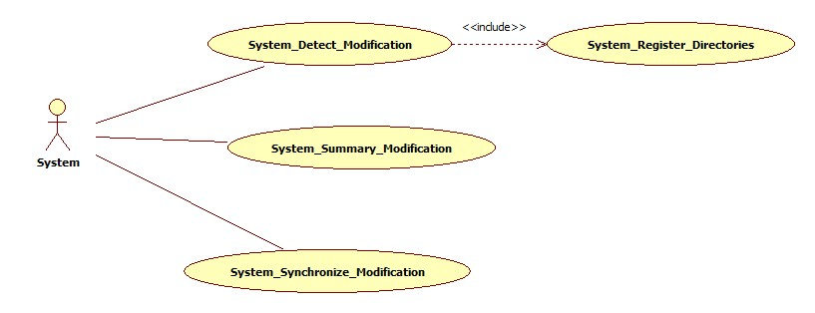
Figure 3. 1 Use case diagram
Use Case #: System_Register_Directories
Description: System register directories which want to detect.
Preconditions: The system has been initialized and locate referenced files
Action: | Software Reaction:
- Read XML document to locate referenced file and htm files. | System will locate all referenced files and all htm files.
- Locate referenced files in all htm files. | System will locate all files and their directories referred in all htm files.
- Register all directories containing all referenced files to detecting service. | System will ready to watch all registered directories.
Postconditions: System are ready to watch all those files.
Table 3. 1 Use case for add appointment

Use Case #: System_ Detect _Modification
Description: System records all alterations when referenced files modified by user.
Preconditions: Files are registered to be detecting.
Action: | Software Reaction:
- User modified referenced files in the file system. | System detects all modifications.
- System records all modification into a log. | A log is created and stored with modifications.
Postconditions: System records all modifications to all referenced files in a log.
Table 3. 2 Use case for edit appointment

Use Case #: System_Summary_Modification
Description: System summaries a series of modifications happened to one specific files.
Preconditions: Files are registered to be watched and system records all modifications to files in a log.
Action: | Software Reaction:
- Extract all modification record from the log. | System gets all modifications.
- Analyze records and merge modifications happened to one specific document. | System gets the merged records.
Postconditions: System gets the final modification of each changed file.
Table 3. 3 Use case for delete appointment

Use Case #: System_Synchronize_Modification
Description: System synchronize all modifications happened in the locale file system to the NovaPIM system.
Preconditions: System gets summarized modifications to files.
Action: | Software Reaction:
- System rewrites modifications into xml file. | Xml of NovaPIM system is updated.
- System rewrites modifications into htm files which contain changed referenced files. | Htm files containing modified referenced files of NovaPIM are updated.
Postconditions: NovaPIM system updated all modified files.
Table 3. 4 Use case for quick add appointment

3.3. Function Analysis

3.3.1. Register files
The detecting service is based on directories instead of specific files. After registering a directory or directories with watch service. The system will notify the file changes, such as, file reaction, file deletion or file modification, happened in these directories. We can register the whole file system on the computer to watch. However, if the system watches all directories in the file system, the system will work inefficiently and slowly due to the high volume of directories in the system. As a consequence, we register the directories which contain referenced file in the NovaPIM system to have watch service.

The NovaPIM system will update all directories containing referenced files which are the targets of detecting in the system automatically at the beginning of each detecting session. Those referenced files consist from two parts. One part is the files referenced in the concept tree left of the system. The other part is referred in all htm files which are referred in the concept tree. As a consequence, system should locate all referenced files and register the directories containing those referenced files to detect the modifications of them. For the first part of the referenced file, system can read the concept tree directly to locate those referenced file and their directories. For the second part of those referenced files, the system has to locate all htm files which contain hyperlinks of other files. And then read all those htm files to locate all hyperlinked referenced files and register their directories.

3.3.2. Detect changes
After system registered all directories as target, the system will detect all changes happened in these files in the detecting session. The system will record all kinds of modifications, such as, file creation, file deletion, and file modifications. Besides, file rename and file move are included in the behavior of file modifications.

Because we register the directories containing referenced files to monitor modifications. So some directories also may contain other non-referenced files. Their alterations also will be recorded by the system. As a result, during the detecting session, we will filter all notifications of non-referenced files.

3.3.3. Summarize modifications
As we all know, in the detecting session, user may change one specific file many times, such as, rename the file and then move it into another directory in the file system. As a result, we should make a summary of all modifications of file changes. We need to merge a series of modifications into one final change with regard to one specific file before synchronize modifications to the NovaPIM system. The merging process can make the NovaPIM system become more efficient. The NovaPIM system will conduct a lot of useless work if synchronize all modifications without a summary.

3.3.4. Synchronize Modification
The final part of the thesis project is to synchronize all modifications to the NovaPIM system. Also the synchronize process will divided into two parts due to there are two parts of referenced files. One part is to synchronize the modifications of the referenced files which referred in the concept tree of the system directly. We will rewrite the xml document which stores the concept tree and replace the changed part of it directly. The other part of the synchronize process is synchronize the modifications of the files which referred in htm files, because user may refer other personal data in the memo (htm files) by using hyperlinks. Once user changed these referenced files out of the NovaPIM system, modifications should also be synchronized to these htm files to make the system work appropriately.

Chapter 4 System Design

4.1. Register Design
The first phrase of register process is to find the directories containing referenced files you want to monitor. Before that we should locate all referenced files in the file system. As mentioned in previous paragraph, referenced files can be divided into two parts. For the first part of files, the system will read the xml document directly and locate all referenced files. During the process, the system also will classify those files into two groups. One group is non-htm files. The other is htm file group. The reason is that user also may refer some files in htm files by using hyperlinks. And then the system will read all htm files to extract all files referred in them. After extracting all paths of referenced file, then the system will locate their directories according the paths of referenced files. Finally, the system will register all those directories to a watch service to monitor changes of all these referenced files.

4.2. Detection Design
Once registered all directories, then, the system are ready to detect modifications to all referenced files. However, before it, the system should declare which types of events it is interested in: file creation, file deletion, or file modification to the watch service. File rename and file movement are also included in the file modification events. With regard to the NovaPIM system, we need not to watch the events of file creation. When user modified one referenced file in the file system outside of the NovaPIM system, the system will record the events into a log. After one detecting session, the log saves all changes happened to referenced files. At the end of each session, the system will read the content in the log to make a summary. At the beginning of each detecting session, the log will be rewritten again.

4.3. Summary Design
After the system record all modifications of referenced files, the system should summaries the records before synchronize those modifications to the NovaPIM system. The reason is that, as we all know, user may occur a series of modification to one specific file during the session. As a result, the system should merge all modifications with regard to each referenced file after each detecting session. If the NovaPIM system synchronize all modifications without summarize them, the NovaPIM system may conduct a great number of redundant work.

For instance, user renamed one document and then moved it into another directory and finally deleted it in the local file system. If the system does not have the summary function, then, the NovaPIM system will synchronize these modifications strictly. It will first rename the file then change the path of its directory and finally delete it. It is obvious that the system can just delete it and disregard how complex the changes happened to it during the process if the system knows that user delete it in advance. What’s more, the summary process can reduce the workload of the NovaPIM system and make it become more efficient. Taking all the aspects discussed before into consideration, it is necessary for the NovaPIM system to summarize the changes before synchronizing them.

4.4. Synchronization Design
Once the system summarized all modifications, the system will prompt one dialog to show the merged changes. It will warn the user the whole modifications happened in the file system to the user during the session. The prototype of the dialog as follows:
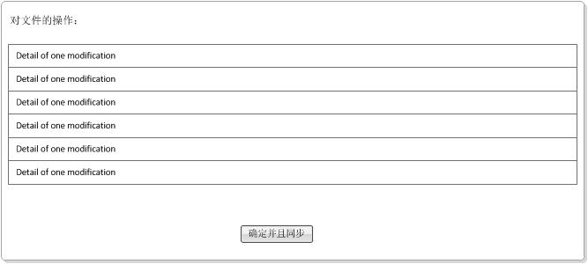
Figure 4. 2 Dialog prototype
The details of one modification include the time, the type of modification, the target file, and the explanation of it which shows the previous and modified condition.

Once the user presses the button in the bottom area of the dialog, the system will begin the synchronize process. In the synchronizing process, the system will read the record of merged modifications one by one and synchronize to the NovaPIM system. As mentioned before, also the synchronizing process will divided into two parts. For the modifications to those files which referred directly in the concept tree in the NovaPIM system, the system will read all the content of the xml document storing the concept tree and rewrite it in another xml file. During the rewrite process, the system will change the hyperlinks of the modified files. After that the system will delete the previous xml file and rename the new xml file to the same name. For the modifications to htm files, to begin with, the system will locate those htm files which contain modified referenced files. Then the system will deal these htm files same as the xml document. The system will read the content of it and rewrite it into another file and change the hyperlinks of modified path in the meantime. At last the system will delete the previous file and rename the new file as same as the previous one.

4.5. Algorithm Design

4.5.1. Analyzing modification events
We use the watch service API offered by JDK7 of Java to figure out the modification events. As we all know, modifications to files can be divided into four categories: create, rename, delete and move. However, the watch service API cannot notify the four exact categories to us. It can only provide the three following categories ^{[8]}:
- ENTRY_CREATE – A directory entry is created.
- ENTRY_DELETE – A directory entry is deleted.
- ENTRY_MODIFY – A directory entry is modified.
As a result, we have to write an algorithm to figure out the common four categories according to the events provided by the API.

After studying that API deeply, I found out some regular pattern of it. Due to we only take care of referenced file in the NovaPIM system so we can discard those files which created by user in the file system during the detecting session. In another name, all files which are referred in the NovaPIM system will not have the creation modification. As a consequence, I will focus on the rest three categories and not list the create events here. The following picture can illustrate the law explicitly.
Rename:
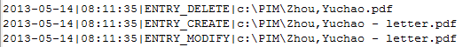
Figure 4. 5. 1 Rename action
Delete:
Figure 4. 5. 2 Delete action
Move:
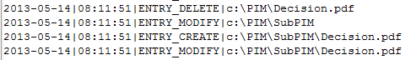
Figure 4. 5. 3 Move action
As these above pictures showing, when user deleted one file, it will output a file deletion event to the changed file; when user renamed one file, it will output a file deletion event to the previous file, a create file event and a modification event with the changed name; when user moved one file into another directory, the system will output a delete event and a modification event in the previous directory and a create event and a modification event in the target directory.

It is obvious that the “ENTRY_MODIFY” event is useless to judge the type of changes, so we can filter this event when we setting the types of events that we want to monitor. In addition, we use the time when events are happened and the path of each event to assist us to distinguish each category of change. Thanks to the recording time, we can judge each event easily.
Finally, we get a regular pattern. At one time, if there is only one record, then we can judge the type of modification quickly. We can just refer the type of event provide by the API. If the type of event provided by the API is “ENTRY_DELETE”, then we can simply define that modification as delete operation. Create operation is the same as this. If there are two records at one time, then we should conduct a judgment to determine the type of modification. We need to pay attention to the path of each events provided by the system. If the file name part of the path of the first event equals the part of the second event, then we can be sure that this is a move operation. Otherwise, it is a rename operation.

Algorithm detail is as following:
- Add time and path to each event while the system output the type of events provided by the watch service API. After the system output all these modification events, then, we will divide these events into groups according to whether the record time are same or not
- Analyze the event or events in the same group to determine the actual type of modification. We will focus on the type of events and the path of changed file. If there is only one record event in one group and the type of the event is “ENTRY_DELETE”, then, we regard it as a delete action. Else if there are two record events in one group and the file part of each event is same, then we regard it as a move action. Otherwise, we regard it as a rename action.
- The system output the final outcome of modifications.

Algorithm: Modification events analyze

Input: time, type and path of each event

Output: type of modification event

1.Step 1. Add time and path output of each event given by watch service API.
2.Step 2. Classify the events according to the time record of them.
3. if the time of several events are same
then divides them into one group
4. Step 3. Analyse every group and figure out the actual type of change.
4. if there is only one event at a time and the type equals “ENTRY_DELETE”
5. then regard it as a delete modification.

6. if there are two events at a time and the file part of the path of the two events are same
7. then regard it as a move modification.
8. else if the file part of the path of these two events are not the same.
9. then regard it as a rename modification.
Figure 4. 5. 4 Algorithm to analyze modification type

4.5.2. Summary modifications
It is a common sense that user may conduct a series of modification to one file during the session. Therefore, it is critical for the system to merge the series of changes occurred to one specific file. It will help the NovaPIM system reduce a great number of redundant workload and improve the efficiency of it.

We employ one data structure called linked list to help us make a summary of all modifications. The node of the linked list is as following:
Figure 4. 5. 5 Node of linked list
The time area records the time when the modification happened, the file area stores the name of the modified file, the type area store the type of the modification, the path1 area store the path of the file before it was modified by user, and the path2 area store the path of the file after it was modified. If it is a delete action, we will set path2 area as null.

We will read the information of all those modifications and establish one node for each modified file. Every time, after we read one modification event from the output of the system, we will traverse all the node of the linked list. If we find the file has already has a node then change the data stored in that node. Otherwise, we will make a new node for that file.

Algorithm details are as following:
- Extract the detail information of one event from the output of the system. If it is the first event, in another word, the linked list is empty. Then use the information of that event to establish one node of the linked list.
- Extract the name of modified file of the next event. In the meantime, traverse every node of the linked list to figure out the latest file name from the path2 area of each node. And compare both of them. During the traversing, we can skip the node which type of it is delete. The reason is that that file has been deleted, and will not be modified anymore.
- If we find the changed file in the linked list, then we will alter the content of that node according to the type of that event. If it is a delete event, we will set the path2 area as null and change the type area of it. If it is a rename event, we will replace the path2 area by the latest path according to the events as same as the move event.
- Finally, we will get a linked list of the merged modifications, every modified file consists one node of that list.

Algorithm: Modifications Summarize

Input: time, type and path of each event

Output: One linked list stores detail of modifications

1. Step 1. Extract the detail of one event and analyze it at one time.
2. if the linked list is empty
3. then establish a new node of the linked list.
4. else traverse the linked list and compare the file part of each node with the detail of the event provided by the system
5. Step 2. Extract the latest file name from the path2 area of the node and judge it with the file part of the events output by the system.
6. if the latest file name equals the file name of one event
7. Step 3. Alter the details of that node according the type of modification.
8. if the type of that event is delete,
9. then alter the type area and delete the path2 area of that node
10. else if the type of that event is rename,
11. then alter the type area and replace the path2 area with the path of that event
12. else if the type of that event is move,
13. then alter the type area and replace the path2 area with the path of that event

14. else if there is no node equals the information of the modification event
15. then establish a new node to store the details of that modification event.

4.5. Index Design

Chapter 5 System Implementation

5.1. Overview

The entire system is written in Java with jdk1.6.0_21 using Integrated Development Environment (IDE) Eclipse. Java Platform, Standard Edition (Java SE) enables us develop and deploy Java applications on multi platform’s desktop systems. Java offers the rich user interface, performance, versatility, portability, and security that today’s applications require. Java SE 6 is the current major release of the Java SE platform. Java SE 7 is available at the development time, but we didn’t choose this new release because most clients haven’t installed the new release yet.

The local database is expected to be Derby (Java DB), so users are supposed to install nothing in the first place. Besides, this project uses JDBC library to connect the program to the Derby.

For the GUI part, Standard Widget Toolkit (SWT) is used to build up GUI elements. In essence, SWT is a compromise between the low-level performance and look and feel of AWT and the high level ease of use of Swing. SWT makes the appearances of widgets accords with the users’ operating system style. SWT has the advantage of being implemented as a native application, which increases the performance and native compatibility of SWT-based GUIs. JFace is a UI toolkit with classes for handling many common UI programming tasks. JFace is window-system-independent in both its API and implementation, and is designed to work with SWT without hiding it. JFace includes the usual UI toolkit components of image and font registries, text, dialog, preference and wizard frameworks, and progress reporting for long running operations. One of its more interesting features is action. The action mechanism allows user commands to be defined independently from their exact whereabouts in the UI.
Draw2d is a layout and rendering toolkit building on top of SWT. It may be used standalone (outside of Eclipse) or in combination with the GEF. Draw2d is a lightweight toolkit for displaying graphical components on an SWT Canvas. Lightweight means that all graphical components, which are called figures in Draw2d, are simply java objects, with no corresponding resource in the operating system.

To implement the calendar system, we need a robust class to represent and manipulate date and time. Joda-Time has been created to radically change date and time handling in Java. The JDK classes Date and Calendar are very badly designed have had numerous bugs and have odd performance effects. Joda-Time is open sourced and licensed under the business friendly Apache License Version 2.0.

To implement the understanding of natural language input to add a calendar entry, Stanford NLP Stanford Named Entity Recognizer and Natty is used to facilitate the process. Stanford NER (also known as CRFClassifier) is a Java implementation of a Named Entity Recognizer. Named Entity Recognition (NER) labels sequences of words in a text, which are the names of things. The software provides a general (arbitrary order) implementation of linear chain Conditional Random Field (CRF) sequence models, coupled with well-engineered feature extractors for Named Entity Recognition. Stanford NER is available for download, licensed under the GNU General Public License (v2 or later). Natty is a natural language date parser written in Java. Given a date expression, natty will apply standard language recognition and translation techniques to produce a list of corresponding dates with optional parse and syntax information. We also use Natty to locate date components in user’s input.

The testing framework I use is JUnit, an open-source testing framework developed by Erich Gamma and Kent Beck [JUnit]. The framework is very simple, yet it allows you to do all the key things you need for testing. Unit test give me the courage to test new things that I could add new function and refractor my code with ease. Eclipse IDE is well integrated with JUnit.
The program will import the external JAR packages:
- org.apache.derby.core_10.8.2.jar
The package contains Embedded Derby database engine and JDBC drivers for connecting to Derby database.
- org.eclipse.swt.win32.win32.x86_3.5.0.v3550b.jar
The package contains libraries for implementing GUI elements using Standard Widget Toolkit.
- joda-time-2.1.jar
The package contains libraries for Joda-Time that provides a quality replacement for the Java date and time classes.
- junit-4.6.jar
The package contains libraries for testing framework.
- lucene-core-3.6.0.jar.jar
The package contains libraries for implementing searching and indexing engine in the system.
- natty-0.6.jar
The package contains libraries for a natural language date parser.
- stanford-ner-2012-04-07.jar
The package contains libraries for Stanford NLP Stanford Named Entity Recognizer.
- org.eclipse.core.commands_3.6.0.I20110111-0800.jar
- org.eclipse.equinox.common_3.6.0.v20110523.jar
- org.eclipse.jface_3.7.0.I20110522-1430.jar
- org.eclipse.jface.text_3.7.1.r371_v20110825-0800.jar
- org.eclipse.osgi_3.7.1.R37x_v20110808-1106.jar
- org.eclipse.ui.workbench_3.7.0.I20110519-0100.jar
These packages contain libraries for JFace framework.
- org.eclipse.draw2d_3.7.2.v20111017-2020.jar
- org.eclipse.gmf.runtime.gef.ui_1.4.1.v20101222-2230.jar
These packages contain libraries for Draw 2D framework.

5.2. Development Tools

5.2.1. Derby (Java DB)
I choose Derby to be used for several reasons. First, Apache Derby, an Apache DB subproject, is an open source relational database implemented entirely in Java, and included in Java SE Development Kit [31]. And as an open source database management system, it has free version easily available from the Internet. Second, Derby enables all the basic database operations, including store, search, sort, and retrieve data. These operations are sufficient for the implementation of the system. It’s also quite convenient to connect to Embedded Derby database by using Java Data Base Connectivity (JDBC). Besides, by using Derby ij, an interactive SQL scripting tool that comes with Derby, it becomes more simple and convenient to manipulate and demonstrate database operations.

3.4.2. Eclipse
Eclipse is a multi-language software development environment comprising an integrated development environment and an extensible plug-in system. Eclipse has two major advantages: open source and extendible plug-ins [28] And The Eclipse platform has many facets and the platform is many different things depending on your particular needs. With Eclipse, I can easily add J2ee libraries to the project. Code auto-prompt function in Eclipse is quite powerful after some modification done to the configuration, and thus it saves a lot of time for writing code. It’s also convenient to import classes necessary for the compilation of the program.

5.2.3. Java
Java is a programming language developed by Sun Microsystems. The language derived much of its syntax from C and C++ but has a simpler object model and fewer low-level facilities. Java applications are typically compiled to byte code that can run on any Java Virtual Machine (JVM) regardless of computer architecture. Java is a general-purpose, concurrent, class-based, object-oriented language that is specifically designed to have as few implementation dependencies as possible.

5.2.4. JDK
JDK is a Sun Microsystems product aimed at Java developers. In order for to develop Java applications, we should first install the Java Development Kit (JDK), which provides necessary tools to compile, execute, debug, document, etc. our programs. JDK is a collection of programming tools, which comes with a complete JAVA Runtime Environment consisting of a Java Virtual Machine and all of the class libraries present in the production environment . The JDK forms the subset of the SDK, which has the responsibility for the writing and running of Java programs. Major components of JDK include as follows:
Java – the loader for Java applications.
Javac – the compiler, which converts source code into Java bytecode.
appletviewer - this tool can be used to run and debug java applets without a web browser
jar – the archiver, which packages related class libraries into a single JAR file.
Jdb – the debugger.

5.2.4. Git and Bitbucket
While this is a medium size project, I have a good habit to have the source code version controlled with Git. Because data is ephemeral and can be lost easily—through an errant code change or a catastrophic disk crash, say—it is wise to maintain a living archive of all work. I also don’t trust the reliability of my computer, so I choose an online code-hosting site Bitbucket for my Git repository.

Git is a particularly powerful, flexible, and low-overhead version control tool that makes collaborative development a pleasure. Git was invented by Linus Torvalds to support the development of the Linux Kernel, but it has since proven valuable to a wide range of projects. Because Git is a distributed version control tool, so I could commits my changes without Internet connection when I was in library, and I could push my changes today to the remote repository when I was online in the dormitory.

Bitbucket is the only free online source code-hosting site I have found. It facilitates browsing and searching my repository from the web. Every commit, directory, file and line gets a unique URL.

5.2.5. Vim
Vim is a highly configurable text editor built to enable efficient text editing. It is an improved version of the vi editor distributed with most UNIX systems. Vim is often called a "programmer's editor," and so useful for programming that many consider it an entire IDE. It's not just for programmers, though. Vim is perfect for all kinds of text editing, from composing email to editing configuration files. Vim is charityware. Its license is GPL-compatible, so it's distributed freely.

5.2.6. Maven
Apache Maven is a software project management and comprehension tool. Based on the concept of a project object model (POM), Maven can manage a project's build, reporting and documentation from a central piece of information. We used Maven to built library natty that is not available elsewhere.

5.3. System Architecture
The Model-View-Controller (MVC) pattern separates the modeling of the domain, the presentation, and the actions based on user input into three separate classes [32]:
Model. The model manages the behavior and data of the application domain, responds to requests for information about its state (usually from the view), and responds to instructions to change state (usually from the controller).
View. The view manages the display of information.
Controller. The controller interprets the mouse and keyboard inputs from the user, informing the model and/or the view to change as appropriate.

A clear division between domain objects that model calendar entry, and presentation objects that are the GUI elements we see on the screen is enforced in the system architecture. Domain objects are completely self-contained and work without references to the presentation.

Our design is a variation of MVC pattern. The passive model is employed because our controller manipulates the model exclusively. The controller modifies the model and then informs the view that the model has changed and should be refreshed. The model in this scenario is completely independent of the view and the controller, which means that there is no means for the model to report changes in its state. This approach is similar to the one that HTTP protocol takes. There is no simple way in the browser to get asynchronous updates from the server. The browser displays the view and responds to user input, but it does not detect changes in the data on the server. Only when the user explicitly requests a refresh is the server interrogated for changes.

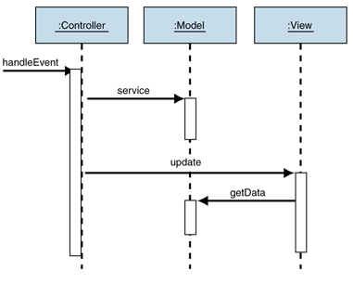
Figure 5. 1 Diagram for showing the Behavior of the passive model.

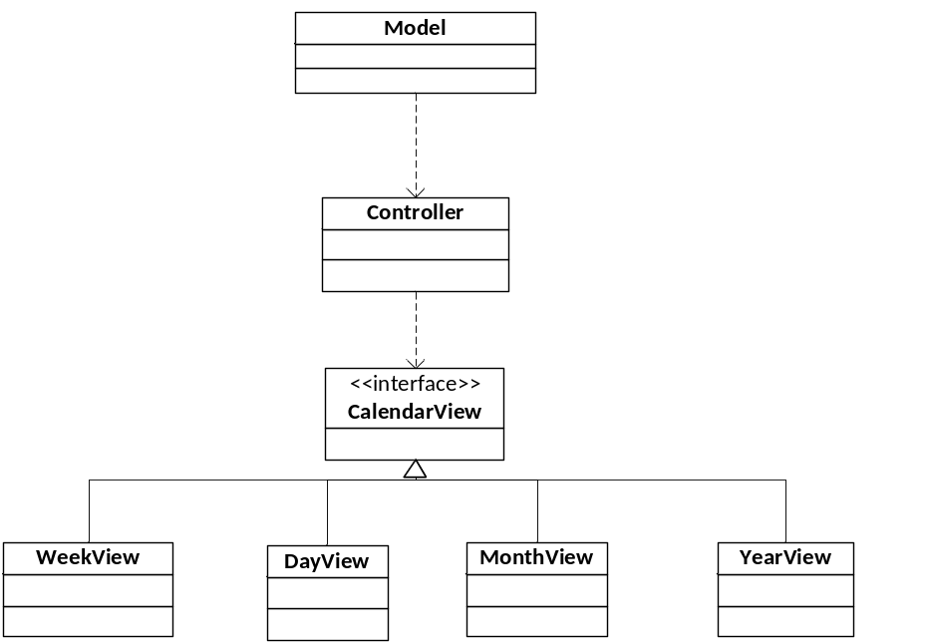
Figure 5. 2 Diagram for showing the structure of the system.
The benefit this variation of MVC pattern is view is completely independent from data model. We could change both the model and view as we wish as long as the interface to update view and get data from controller remains unchanged.
Architecting the presentation layer around the MVC pattern result in the following benefits and difficulties:

Benefits
Supports multiple views. Because the view is separated from the model and there is no direct dependency from the model to the view, the user interface can display multiple views of the same data at the same time. This program needs four views to display calendar information but use the same model objects. These views display the same data from the shared model, but show it in a different way.
Accommodates change. User interface requirements tend to change more rapidly than business rules. Because the model does not depend on the views, adding new types of views to the system does not affect the model. This system is a good example, different views could be added without affecting any of the data model. As a result, the scope of change is confined to the view. Besides, all the views are independent of other views; one change will not affect other views.

Difficulties:
Complexity. The MVC pattern introduces new levels of indirection so increases the complexity of the solution slightly. It also increases the event-driven nature of the user-interface code, which can become more difficult to debug.
Cost of frequent updates. Decoupling the model from the view does not mean that developers of the model can ignore the nature of the views. For example, if the model undergoes frequent changes, it could flood the views with update requests. Some views, such as graphical displays, may take some time to render. As a result, the view may fall behind update requests. Therefore, it is important to keep the view in mind when coding the model. In this system, we have the option to only update a portion of the whole view. For example, we could choose to only update current day’s view.

5.4. Class Diagram
There are forty-nine classes in total to implement the project. The classes can be divided into nine categories, including GUI related classes, action class, utility classes, common classes, model related classes, database related classes, NLP related classes and search related classes. The MainWindow.java is the class that initiates the whole program.

GUI related classes are further divided into common classes, day view classes, month view classes, week view classes, year view classes, and utility classes. The common classes include EventList.java, AllDayEventList.java, CalendarView.java, ControlPanel.java, GotoDateDialog.java and NewEventDialog.java, SearchResultDialog.java, SwitchPanel.java. Day view classes include DayCanvas.java, DayView.java, DayViewLeftComp.java, EventRectangle.java, FigureActionHandler.java, and TranslucentRoundedRectangle.java. Month view classes include DayInMonthComposite.java, MonthView.java, and OneMonth.java. Week view classes include WeekCanvas.java and WeekView.java. Year view classes include MonthInYear.java, MyRectangleFigure.java, and YearView.java. These classes initiate GUI frames for displaying information.

Action classes are used to respond to the events of those GUI frames, including ActionRepository.java, EditEventAction.java, GotoDateAction.java, GotoTodayAction.java, NewEventAction.java, NextAction.java, PreviousAction.java, and SearchAction.java.

Utility classes are responsible for managing constants and common computation tasks, including CalConst.java, ComputationHelper.java, and ConvertUtil.java.

Common classes are responsible for miscellaneous tasks, including IOHelper.java, PrefName.java, Prefs.java, Resource.java, and Warning.java.

Model related classes are responsible for data model that represent calendar entry and option entry in the system, including CalendarOption.java and EventEntity.java.

Database related classes are responsible for tasks that involve database processing, including EventDB.java and JdbcDB.java.

NLP related classes are responsible for natural language processing in adding quick entry, including NERDemo.java.

Search related classes are responsible for full-text search function, including Indexer.java, SearchDialog.java and SearcherLucene.java.

5.4.1. Relationship between all classes
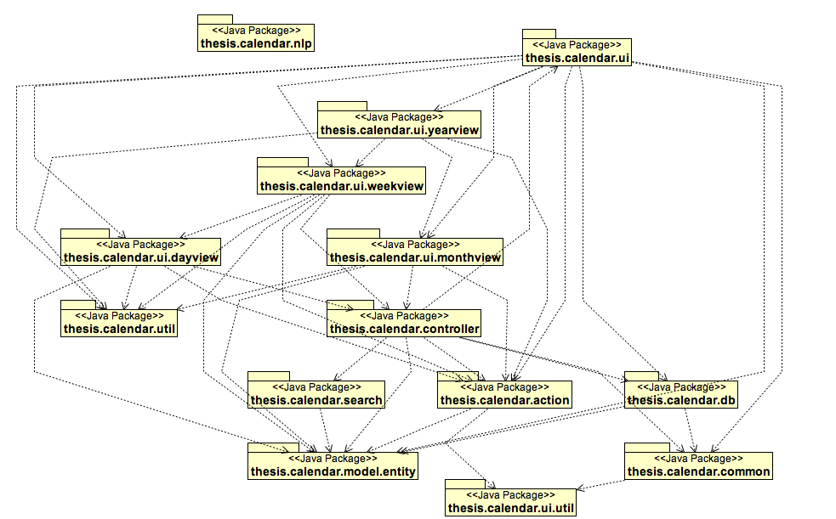
Figure 5. 3 Diagram for showing the internal relationships between all the packages.
All fifty classes will never fit clearly in a figure. So I first try to demonstrate the relationship between all packages. Thesis.calendar.ui package contains the MainWindow.java class that initiates the whole program, and then the JdbcDB.java class will connect to database. The connection process will verify the timestamp of last shutdown. Then initiate the EventController.java class. In the initiation process, events information will be add to the indexer. Until now, all calendar information will be available for other classes. Day view is the default view. The view class DayView.java will fetch event information from EventController.java class and update graphical user interface. User’s actions may trigger one of action classes in thesis.caldendar.action package. Calendar Entry is represented as EventEntity.java class in the system. If user click add event, NewEventDialog.java class will be initiated, and Dialog displayed. If user click ok button after input required information, the action class NewEventAction.java will be triggered, then the addEvent method in EventController.java class will be triggered, and then addEvent method in EventDB.java class.

5.4.2. MainWindow.java Class
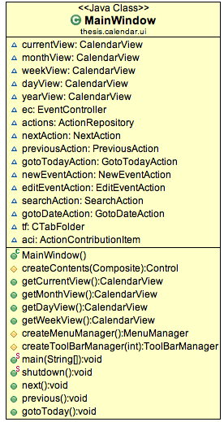
Figure 5. 4 Diagram of MainWindow.java
This class provides the main function and will execute before all the other classes. In the main(String[] args) method initiate database and the graphical user interface. The shutdown() method is for close the database connection before close the program. The getCurrentView() method is used to get the current calendar view displayed to the user. createMenuManager() method will populate the menu in graphical user interface. createToolBarManager() method will populate the toolbar in main window. All widgets in the main window is created in createContents() method.

5.4.3. EventController.java Class
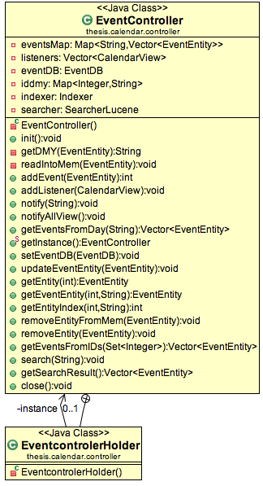
Figure 5. 5 Diagram for class EventController.java
This class is the controller class as a bridge between model and view. It implements the Singleton design pattern. It requires that a class has only one instance, and provides a global point of access to it. EventControlerHolder will have a instance variable, and EventController will only initiate once and lately all the request to get EventController instance will trigger getInstance() method in EventController. getInstance() is the only global point of access to the only one instance. All calendar entry related add, remove, update operations have corresponding methods in this class.

Observer design pattern is also implanted here. Day, week, month, year views all implement CalendarView.java interface. All these views listen to the changes in data model. So these views registered here in EventController class by call addListener(CalendarView):void method. All the changes to data model will go through methods in this class, so any change to the data model will notify the view.

This class also facilitate search functionality, there are two methods: search(String):void and getSearchResult():Vector<EventEntity>.

5.4.4. CalendarView.java Class
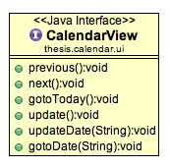
Figure 5. 6 Diagram for CalendarView.java class
This class defines all the method that a calendar view has to implement. This class enables polymorphism in our object-oriented design. Most of our code use CalendarView as placeholder instead of DayView, MonthView, YearView, and WeekView specifically. Previous, next, gotoDate methods will change date of the calendar view. Update will update the view to show new changes in data model. UpdateDate method will update a specific date in the calendar view, other date will not be influenced.

5.4.5. JdbcDB.java Class
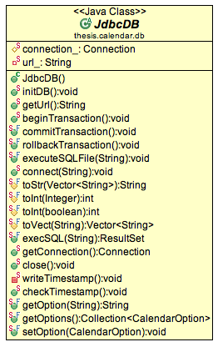
Figure 5. 7 Diagram for class JdbcDB.java
This class is the abstract base class providing basic common JDBC services to all derived database classes. It has the common database connection shared by all sub-classes. Every sub-class of JdbcDB in this system will manage a table in database. The connect method is the one that start the connection to database, verify the integrity of every table, and build the tables that not exist. The execSQL(String):ResultSet method will be used by all sub-classes to execute SQL statements. There are four conversion methods in this class to ensure the conversion from Java type to database type is unified. WriteTimestamp and checkTimeStamp methods are used to verify the integrity of the database.

5.4.6. EventDB.java Class
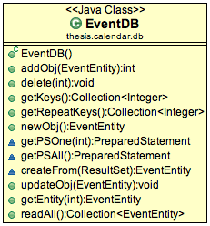
Figure 5. 8 Diagram for class EventDB.java
The class implements all the database operations for the calendar entries in whole project. The addObj method is to add calendar entry into the database. The delete method is to delete the calendar entry from the database. The getKeys method will return all calendar entry ids. The updateObj method is to update one calendar entry. The readAll method is to read all calendar entries into memory.

5.4.7. Indexer.java Class
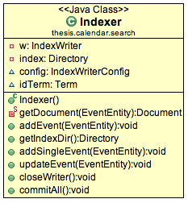
Figure 5. 9 Diagram for Indexer.java
The class is to index all calendar entries. The addEvent method is to add a calendar entry to the indexer. The updateEvent method is to update one calendar entry in the indexer. Note that changes will still be flushed to the Directory as new files, but are not committed until commitAll() is called. Because the calendar entries data is small enough to stay in modern memory, we choose RAMDirectory as index store. It could be explained as that the EventController is feeding text data to the indexer. The getDocument method is to build the document that consists of several separately named fields with values.

5.4.8. SearcherLucene.java Class
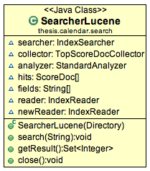
Figure 5. 10 Diagram for class SearcherLucene.java
This class is in charge of building query, searching query and rendering search results. The first two steps are in the search method. The last step is in the getResult method. The search method first checks whether the index has been changed since opened last time. If the index has been changed, a new IndexSearcher will be initialized with the new IndexReader. Then the query will be built through MultiFieldQueryParser and a TopScoreDocCollector will be created to collect the documents found. Then this method will call the search method in IndexSearcher class.

5.4.9. EventRectangle.java Class
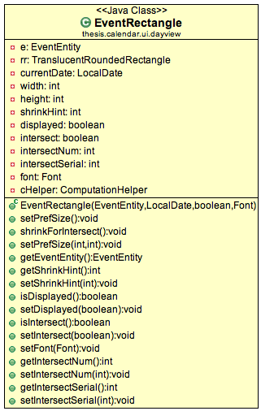
Figure 5. 11 Diagram for class EventRectangle.java
This class is the graphical representation of a calendar entry in day view and week view. There is method for controlling display when two events are overlapping in time space. The algorithm is detailed in the previous chapter.

5.5. System management module implements

5.5.1. Challenge in implementation

5.5.1.1 Calendar entry span multiple days
Calendar entry that spans multiple days is constantly a difficult problem to solve in calendar management system. Traditionally, people may store multiple calendar entries to achieve this function. In our data model, one calendar entry can only exist one place. We believe in Don't Repeat Yourself principle. This principle could be stated, as “Every piece of knowledge must have a single, unambiguous, authoritative representation within a system”. [33]

In this system, the data model reshape the data read from database into two separate Map structure. One map DateEntriesMap is from date to set of calendar entry ids. Another map IDEntryMap is from calendar entry id to calendar entry.

When the system loads the data from database, it will first add the calendar entry to the IDEntryMap. Then the algorithm will check all the days that calendar entry spans and add this calendar entry to all the set of the dates in DateEntriesMap.

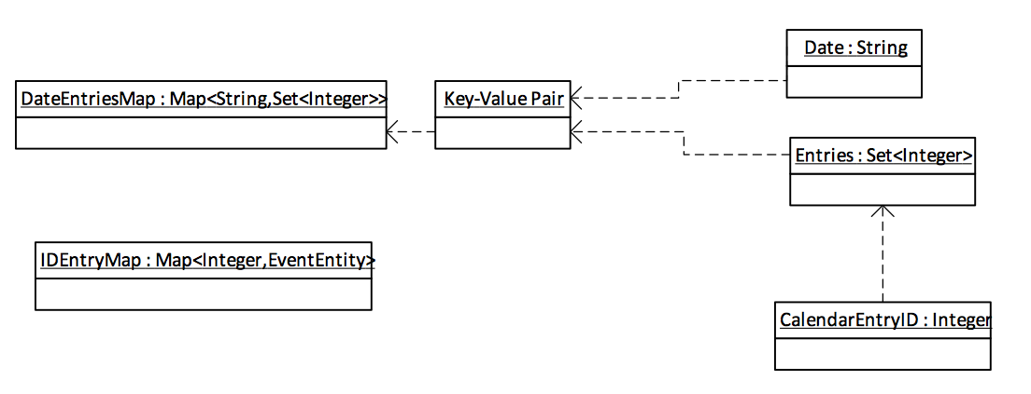
Figure 5. 12 Diagram for showing the structure of the model.
The cost of a calendar entry that span multiple days is only more calendar entry ids that in several corresponding set in DateEntriesMap.

5.5.1.2 Effort to reuse code
In the implementation of this system, I have paid a lot of attention to reuse code. One reason is to save the time in development. Another reason is to keep same code in one place to apply the DRY principle. When the Don’t Repeat Yourself principle is applied successfully, a modification of any single element of a system does not require a change in other logically unrelated elements.

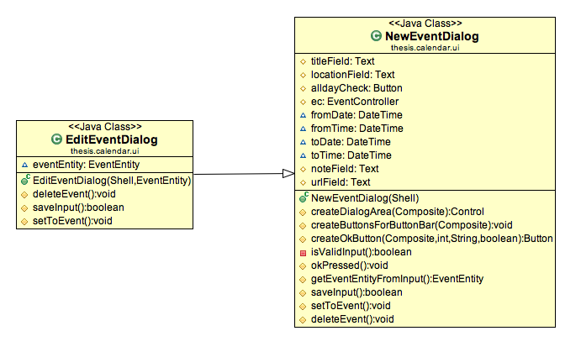
Figure 5. 13 Class diagram for showing the relationship between EditEventDialog and NewEventDialog.
To apply the Don’t Repeat Yourself principle further, I extract most commonly used classes into three packages.
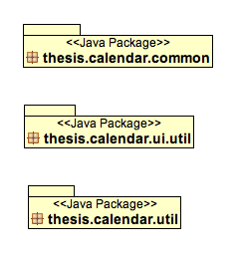
Figure 5. 14 Class diagram for showing the packages contain extracted commonly used classes.

5.5.3. Add a new event implementation

5.5.3.1. Function description
Users are required to input the title, from date-time, to date-time and other optional fields like location, URL, and note. The system first creates an EventEntity object for user’s input. The created EventEntity object will be stored in memory and in the database. It also will be indexed in the process. All the views will get notified for this event.

5.5.3.2. Activity diagram
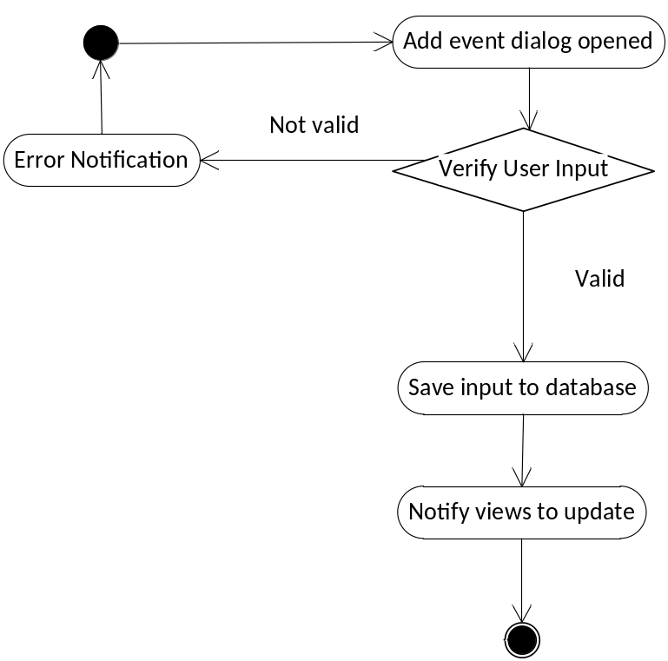
Figure 5. 15 Activity diagram for add new calendar entry.

5.5.3.3 GUI Implement
Users are required to enter the information about a calendar entry. The interface is shown below.
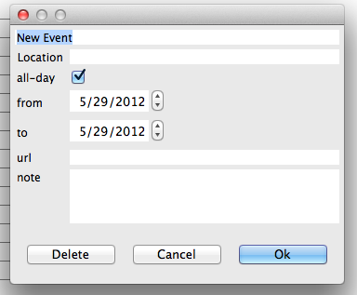
Figure 5. 16 Interface for user to calendar entry information and user account

5.5.3.4. Code explanation
There are five classes involved in realizing this function, i.e. NewEventAction.java, NewEventDialog.java, EventController.java, EventEntity.java and EventDB.java.
The functionalities of each class are as follows:
- NewEventAction.java is to action class that used by JFace framework.
- NewEventDialog.java is the class for new event dialog graphical user interface class.
- EventController.java is the class responsible for all communications between graphical user interface and data model.
- EventEntity.java is the class represent calendar entry in the system.
- EventDB.java is the class in charge of communication to the calentries table in database.
/*
* Class: EventController.java
*
* In charge of all communications between graphical user interface and data model
*
* @author Xiaoyi Chen(ZJUT)
*/
private void readIntoMem(EventEntity e){
String dmy = getDMY(e);
iddmy.put(e.getId(), dmy);
Vector<EventEntity> eList = eventsMap.get(dmy);
if(eList!=null){
eList.add(e);
eventsMap.put(dmy, eList);
}else{
Vector<EventEntity> newList = new Vector<EventEntity>();
newList.add(e);
eventsMap.put(dmy, newList);
}
notify(dmy);
}

public int addEvent(EventEntity e){
int id = -1;
try {
id = eventDB.addObj(e);
assert(id!=-1);
e.setId(id);
indexer.addSingleEvent(e);
}catch (Warning e1) {
e1.printStackTrace();
//UIErrorHandler.getInstance().notice(e1.getMessage());
} catch (Exception e2) {
e2.printStackTrace();
//UIErrorHandler.getInstance().errmsg(e2);
}
readIntoMem(e);
return id;
}

5.5.4. Display event in views implementation

5.5.4.1. Function description
This function is to display overlapping events in the canvas and ensure user could select every event easily. Standard widgets are not sufficient for our design goal. We need the freedom to arrange events corresponding to the details of the events. All events in day view and week view are displayed using this function.

5.4.2.2. Activity diagram
The activities would follow the sequence as follows:
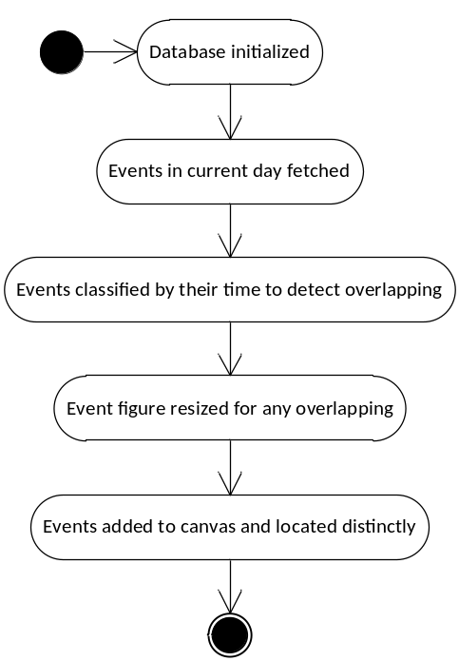
Figure 5. 17 Activity diagram for displaying overlapping events in day view

5.5.4.3 GUI Implement
First, all the events are displayed as transparent rounded rectangle. If no events exist at the same time, the events figure will take up all the horizontal space.

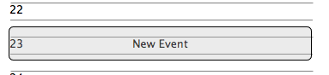
Figure 5. 18 One Event at a time
Second, if events exist at the same time, the event figures will all take up part of all the horizontal space.
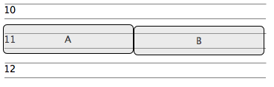
Figure 5. 19 Two events at a time

Third, the distance of the start time of two events is more than 15 minutes. The two events can be displayed clearly as normal. Users could open each one of the events by double clicking.
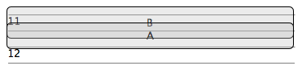
Figure 5. 20 Two events overlapping partly.

5.5.4.4. Code explanation
There are five classes involved in realizing this function, i.e. DayView.java, DayCanvas.java, EventRectangle.java, TranslucentRoundedRectangle.java, EventEntity.java and EventEntity.java

- DayView.java is the class that contains implementation of day view graphical user interface.
- DayCanvas.java is the class that contains implementation of the canvas to display non all-day events.
- EventRectangle.java is the class implements a graphical representation of a non all-day event.
- TranslucentRoundedRectangle.java is the class implements a translucent rounded rectangle figure.
- EventController.java is the class responsible for all communications between graphical user interface and data model.
- EventEntity.java is the class represents calendar entry in the system.

/*
* Class: DayCanvas.java
*
* This class contains implementation of the canvas to display non all-day events.
*
* @author Xiaoyi Chen(ZJUT)
*/

public void update(){
clear();
alldayList.setDate(localDate);
Vector<EventEntity> eventEntities = ec.getEventsFromDay(localDate.toString());
if(eventEntities==null)
return;
//System.out.println(eventEntities);
for(EventEntity e : eventEntities){
addEventEntity(e);
}
checkIntersects();
flushToDisplay();
}

private void flushToDisplay() {
// TODO Auto-generated method stub
for(EventRectangle er :eventFigures){
er.shrinkForIntersect();
if(!er.isDisplayed()){
primary.add(er,new Rectangle(getRecLocation(er),er.getPreferredSize()));
er.setDisplayed(true);
}
}
}

public void addEventEntity(EventEntity e){
if(e.isAllday())
return;
EventRectangle er = new EventRectangle(e,localDate,true,this.getFont());
String fromTimeString = simpleTimeString(e.getFromDateTime());
Vector<EventRectangle> ev = counts.get(fromTimeString);
if(ev==null){
ev = counts.get(simpleTimeString(e.getFromDateTime().minusMinutes(15)));
if(ev==null){
ev = counts.get(simpleTimeString(e.getFromDateTime().plusMinutes(15)));
if(ev==null){
ev = new Vector<EventRectangle>();
}
}
}
ev.add(er);
counts.put(fromTimeString, ev);
eventFigures.add(er);
}

private void checkIntersects() {
// TODO Auto-generated method stub
for(String timeString : counts.keySet()){
Vector<EventRectangle> erv = counts.get(timeString);
int i = 0;
for(EventRectangle er : erv){
er.setIntersectNum(erv.size());
er.setIntersectSerial(i);
er.setIntersect(true);
i++;
}
}
}

Chapter 6 System Test

6.1. Overview
The test plan is composed of automated test using JUnit and manual test cases. The automated test is to ensure the core component of the system is working as expected in every version of the code. The automated test should be passed after every major change to the code. The manual test cases are to ensure the function of the system is as expected as the requirement.

6.1. Automated Test using JUnit
The primary test task is to ensure the data model and the controller is working as we expect. Therefore, the design of testing is around fetching, adding, deleting appointment from the data model. The database access class and the controller class is tested separately.

The database access class is EventDB class. The test code firstly adds an event to the database through addObj method, then fetch the added event from the database by event id, and all details of the original event object and fetched event object are compared and verified. Then the test code deletes the event object from the database.

The process for testing controller class is similar.

6.2. Manual test cases
This part of test is called Black box testing and more specifically specification-based testing. The test is aimed to test the functionality of software according to the applicable requirements. Thus, the tester inputs data into, and only sees the output from, the test object. This level of testing usually requires thorough test cases to be provided to the tester, who then can simply verify that for a given input, the output value (or behavior), either "is" or "is not" the same as the expected value specified in the test case.

6.2.1 Connect to database

This is to test successfully connect to database.
Operation | Expected result | Test result | Conclusion
Start the program | Connect to database successfully and verify the timestamp | As expected | Passed
End the program | Disconnect to database and write the timestamp to preference and database option table | As expected | Passed
Table 6. 5 Test case for connecting to database

6.2.2 Add appointment
This is to test add an appointment, and write the information of the appointment to the database calentries table.
Operation | Expected result | Test result | Conclusion
All the necessary part is inputted and the from time is before the time | The appointment added to the database and displayed correctly | As expected | Passed
Some part is missing | Use default value to replace the missing part | As expected | Passed
The from time is after the to time | Remind user to change the from time or the to time | As expected, the reminder showed | Passed
Table 6. 6 Test case for adding appointment

6.2.3 Display appointment
This is to test display appointments in views, especially events that spans multiple days.
Operation | Expected result | Test result | Conclusion
Add a all-day appointment | The appointment is displayed in all-day list in day, week, and month views | As expected | Passed
Add a non all-day appointment | The appointment is displayed as a figure in day and week views, and the size could reflect the span of the appointment and the start time of the appointment. | As expected | Passed
Add a non all-day appointment spans multiple days | The appointment is displayed as a figure in day and week views, and the size could reflect the span of the appointment and the start time of the appointment. | As expected | Passed
Table 6. 7 Test case for display appointment

6.2.3 Add quick appointment
This is to test the natural language processing part of system.
Operation | Expected result | Test result | Conclusion
Input “Meet Yang tomorrow” | The add event dialog showed with title “Meet Yang”, from time set to tomorrow date and all-day is checked. | As expected | Passed
Input “Go to school at ZJUT tomorrow 7:00” | The add event dialog showed with title “Goto school”, location “ZJUT”, from date-time tomorrow 7:00, and all-day is unchecked. | As expected | Passed
Table 6. 8 Test case for adding quick appointment

Chapter 7 Conclusion
The system achieves basic goals in the thesis proposal including personal calendar management More importantly, the system fulfills the purpose of the natural language processing in add quick entry. The graphical user interface designed using SWT widget toolkit is also pleasant to look.

The manipulation of the system is quite simple to grasp. Users get clear feedback after each operation is done so that they know exactly what the result of their last operation is. The layout of the GUI is also clear and users can quickly find the button for each function. Besides, the system has pleasant appearances, which accords with the style of the operating system.

Throughout the implementation of the project, I myself also learned a lot. First, before the project, I have little idea about natural language processing, which now seems quite make sense to me. By reading the book Speech and language processing: An Introduction to Natural Language Processing, I learned basic concepts in natural language processing and also learned the usage of a great tool set from Stanford NLP. With this experience, I also improved my self-teaching ability, which would be extremely helpful even after graduation. Besides, I also developed interest in machine learning, which might lead me to pursue degree in the academic world of machine learning in the future.

Reference
- W. Jones. Finders, keepers? The present and future perfect in support of personal information management. First Monday,2004,http://www.firstmonday.dk/issues/issue9_3/jones/index.html.
- M. Lansdale. The psychology of personal information management. Applied Ergonomics, 19(1), 1988, pp.55-66.
- V. Bush. As we may think. Atlantic Monthly, 176(1), July 1945, p:101-108.
- S. Dumais, E. Cutrell, J. J. Cadiz, G. Jancke, R. Sarin, D. C. Robbins. Stuff I've seen: a system for personal information retrieval and re-use. SIGIR conference, 2003, pp.72–79.
- J. Gemmell, G. Bell, R. Lueder, SM Drucker, C. Wong. MyLifeBits: Fulfilling the Memex vision. Proc. of the 10th ACM International Conference on Multimedia, 2002, pp.235-238.
- L. Blunschi, J. Dittrich, O. R. Girard, S. K. Karakashian, and M. A. V. Salles. A Dataspace Odyssey: The iMeMexPersonal Dataspace Management System. CIDR, 2007, pp.114-119.
- Liang Huai Yang, Jian Zhou, Jiacheng Wang. A Novel PIM System and its Effective Storage Compression Scheme. Journal of Software, 7(6):1385-1392,2012.
- http://docs.oracle.com/javase/tutorial/essential/io/notification.html

Reference
[1] Payne, S. J. (1993). Understanding Calendar Use. Human-Computer Interaction, 8(2), 83-100. Taylor & Francis.
[2] Tungare, M., Perez-Quinones, M., & Sams, A. (2008). An Exploratory Study of Calendar Use. Management Information Systems, 08(3), 277-297.
[3] Karger, D. R., Bakshi, K., Huynh, D., Quan, D., & Sinha, V. (2005). Haystack: A customizable general-purpose information management tool for end users of semistructured data. Proc of the CIDR Conf, 13-27. Citeseer.
[4] Cai, Y., Dong, X. L., Halevy, A., Liu, J. M., & Madhavan, J. (2005). Personal information management with SEMEX. Proceedings of the 2005 ACM SIGMOD international conference on Management of data SIGMOD 05, 921. ACM Press.
[5] Boardman, R., Sasse, M. A., & Anonymous. (2004). “Stuff goes into the computer and doesn’t come out": a cross-tool study of personal information management. Proceedings of the SIGCHI conference on Human factors in, Vienna, Au, 583-590. ACM Press.
[6] KELLEY, J. F. and CHAPANIS, A. (1982), How professional persons keep their calendars: Implications for computerization. Journal of Occupational Psychology, 55: 241–256.
[7] Lin, M., Lutters, W. G., & Kim, T. S. (2004). Understanding the Micronote Lifecycle : Improving Mobile Support for Informal Note Taking. Proceedings of the ACM Conference on Human Factors in Computing Systems (Vol. 6, pp. 687-694). ACM.
[8] Cheyer, A., Park, J., & Giuli, R. (2005). IRIS: Integrate, Relate, Infer. Semantic Desktop Workshop at the ISWC (Vol. 175).
[9] Karger, D. R., & Jones, W. (2006). Data unification in personal information management. (W. Jones & J. Teevan, Eds.)Communications of the ACM, 49(1), 77-82. ACM Press.
[10] Jones, W., Karger, D., Bergman, O., Franklin, M., Pratt, W., & Bates, M. (2005). Towards a Unification & Integration of PIM Support.
[11] Sauermann, L. (2009). The Gnowsis Semantic Desktop approach to Personal Information Management. Citeseer. Technischen Universitat Kaiserslautern.
[12] Eric Freeman and David Gelernter. Lifestreams: A storage model for personal data. SIGMOD Record (ACM Special Interest Group on Management of Data), 25(1):pp80, 1996.
[13] Cruz, I. F., & Xiao, H. (2008). A layered framework supporting personal information integration and application design for the semantic desktop. The VLDB Journal, 17(6), 1385-1406. Springer-Verlag New York, Inc.
[14] Alliance, O. (2011). OSGi Service Platform Core Specification The OSGi Alliance. Cycle, 2011(April). http://www.osgi.org/.
[15] Kaviani, N., Mohabbati, B., Lea, R., Gasevic, D., Hatala, M., & Blackstock, M. (2009). ReCoIn : A Framework for Dynamic Integration of Remote Services into a Service-Oriented Component Model. Computing, 502-507.
[16] Tavares, A. L. C., & Valente, M. T. (2008). A gentle introduction to OSGi. ACM SIGSOFT Software Engineering Notes, 33(5), 1-5. ACM.
[17] Jeff McAffer, Paul VanderLei, and Simon Archer. 2010. Osgi and Equinox: Creating Highly Modular Java Systems (1st ed.). Addison-Wesley Professional.
[18] Jeff McAffer and Jean-Michel Lemieux. Eclipse Rich Client Platform: Designing, Coding, and Packaging Java(TM) Applications (2nd Edition). Addison-Wesley Professional, May 2010.
[19] OSGi Alliance. http://www.osgi.org. Feb 2012.
[20] Eclipse Equinox. http://eclipse.org/equinox/. Feb 2012.
[21] Eclipse. Whitepaper: Component Oriented Development and Assembly with Equinox. http://eclipse.org/eclipsert/whitepaper/20080310_equinox.php. Feb 2012.
[22] Bellotti, V., Ducheneaut, N., Howard, M., & Smith, I. (2003). Taking email to task: the design and evaluation of a task management centered email tool. Victoria (Vol. 6, p. 352). ACM.
[23] Mik Kersten and Gail C. Murphy. 2006. Using task context to improve programmer productivity. In Proceedings of the 14th ACM SIGSOFT international symposium on Foundations of software engineering (SIGSOFT '06/FSE-14). ACM, New York, NY, USA, 1-11.
[24] Kersten, M. (2007). Focusing knowledge work with task context. Knowledge Creation Diffusion Utilization. University of British Columbia.
[25] Eclipse Mylyn. http://www.eclipse.org/mylyn/.
[26] Boardman, R., Spence, R., & Sasse, M. A. (2003). Too many hierarchies? The daily struggle for control of the workspace. In J. Jacko & C. Stephanidis (Eds.), Proc HCI International 2003 (Vol. 1, pp. 616-620). Citeseer.
[27] MySQL, Wikipedia, http://en.wikipedia.org/wiki/MySQL
[28] Eclipse (software), Wikipedia, http://en.wikipedia.org/wiki/Eclipse_(software)
[29] Java, Wikipedia, http://en.wikipedia.org/wiki/Java_(programming_language)
[30] Java Development Kit, Wikipedia,
http://en.wikipedia.org/wiki/Java_Development_Kit
[31] Apache Derby, Apache, http://db.apache.org/derby/
[32] Burbeck, Steve. "Application Programming in Smalltalk-80: How to use Model-View-Controller (MVC)."University of Illinois in Urbana-Champaign (UIUC) Smalltalk Archive. Available at: http://st-www.cs.illinois.edu/users/smarch/st-docs/mvc.html.
[33] Dave Thomas, interviewed by Bill Venners (2003-10-10). "Orthogonality and the DRY Principle". Retrieved 2006-12-01.
[34] Parr, Terence (May 17, 2007), The Definitive Antlr Reference: Building Domain-Specific Languages (1st ed.), Pragmatic Bookshelf, pp. 376, ISBN 0-9787392-5-6

Bibliography
Daniel Jurafsky and James H. Martin Speech and language processing: An Introduction to Natural Language Processing, Computational Linguistics, and Speech Recognition, 2nd edition, Pearson Prentice Hall, 2008.

MACIASZEK, L.A. and LIONG, B.L., Practical Software Engineering, A Case Study Approach(2005), Harlow England, Addison-Wesley, 864p. (ISBN 0-321-20465-4).

Ian Sommerville, Software Engineering, Addison Wesley, 9th Edition.

S.L. Pfleeger, Software Engineering: Theory and Practice, Prentice Hall.

D. Yardley, Successful IT Project Delivery, Addison-Wesley Professional.

Sharp, Rogers, and Preece, Interaction Design, Wiley, 2nd edition.

Acknowledgement
During the proceeding of this project, I am very thankful to those who helped. Many thanks to my project advisor: Lianghuai Yang, Full Professor of Computer Science & Technology department from my university. With cutting edge research experience in the field of personal information management, Professor Yang inspired me with this project and enlightened me with fundamental knowledge about personal information management. Professor Yang also provided me with high quality essays relating to personal information management system, which I think is a treasure condensed from the work of many brilliant researchers in this field. Professor Yang also guided me about the correct way of essay writing, so that my essay looks as standardized as possible. Professor Yang also pointed out the shortages of this project so that I am able to improve the quality of the project. Professor Yang provides me both the basic skills to craft better graphical user interface and the overall guidance to advance the project. His great research experience in database field offered me a lot of ideas not only boost the development of this project, but also help me identify the future path of my academic career.

I’m very glad to the Professor Huiqiang Lv, who always provides critical and positive suggestions to my study life. I will not finish this project in time without the help from Professor Huiqiang Lv.

I’m also grateful to the Professor who examined my project in April. He proposed many brilliant advices about my project and essay, so that I am able to further perfect the essay and program alike.

Appendix

Additional Class Diagrams

DayView.java Class
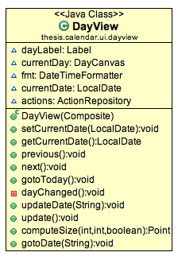
Appendix 1 Diagram for class DayView.java
DayView.java is the class that contains implementation of day view graphical user interface.

DayCanvas.java Class
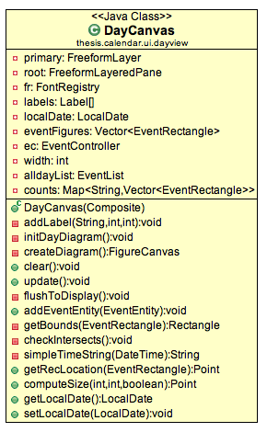
Appendix 2 Diagram for class DayCanvas.java
DayCanvas.java is the class that contains implementation of the canvas to display non all-day events.

TranslucentRoundedRectangle.java Class
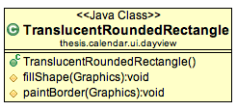
Appendix 3 Diagram for class TranslucentRoundedRectangle.java
TranslucentRoundedRectangle.java is the implementation of the figure that is translucent and rounded rectangle that used to display event in day view and week view.

EventEntity.java Class
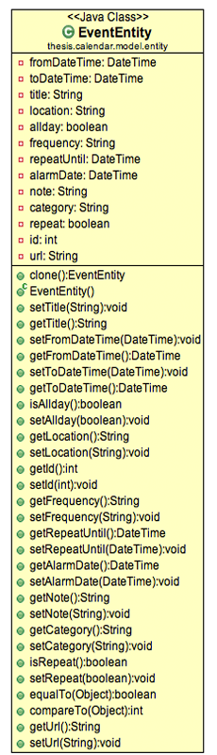
Appendix 4 Diagram for class EventEntity.java
This class is the representation of calendar entry in this system.

